# **Planning and Progress Report**

**Group:** C1.027  
**Repository:** [AirNav-Logistics](https://github.com/DP2-C1-027/AirNav-Logistics)**Date:** February 15, 2025

### **Group Members:**

1. **Garcia de Tejada Delgado, Jose**
   * Role: Developer
   * Email: josgardel8@alum.us.es
2. **Peñaloza Friqui, Nora**
   * Role: Developer
   * Email: norpennfri@alum.us.es
3. **Niza Cobo, Manuel Jesús**
   * Role: Manager, Developer
   * Email: mannizcob@alum.us.es
4. **Gomez Claraco, Nicolas**
   * Role: Developer
   * Email: nicgomcla@alum.us.es
5. **Campos Diez, Lucia**
   * Role: Tester, Developer
   * Email: luccamdie@alum.us.es

## **Table of Contents**

1. **Executive Summary**
2. **Revision Table**
3. **Introduction**
4. **Planning Chapter**
   * Tasks Performed
   * Estimated Budget
5. **Progress Chapter**
   * Progress Records
   * Conflicts and Resolution
   * Cost Comparison
6. **Conclusions**
7. **Bibliography**

## 

## 

## 

## 

## 

## 

## 

## 

## 

## 

## 

## 

## **Executive Summary**

This report is intended to provide an overview of the analysis, planning, and advancement of the AirNav-Logistics project, which is being developed to establish a complete logistics management system for charter flights at airports. The document outlines the tasks completed, the status of various features, and both the projected and actual budget. Additionally, it discusses the development methodology, challenges faced during the process, and compares the estimated versus actual costs. The aim is to confirm that the project is progressing as planned, within the set timeline and budget.

## **Revision Table**

|  |  |  |
| --- | --- | --- |
| **Revision** | **Date** | **Description** |
| 1 | 11/02/2025 | Creation of the analysis, planning, and progress report. |

## **Introduction**

This report provides an overview of the analysis, planning, and progress made in the AirNav-Logistics project, developed by group C1.027. The objective of the project is to create a system that supports airports in managing resources for charter flights. The report is organized into two sections: planning and progress, which offer a detailed description of the tasks assigned, their execution, related costs, and the conflicts managed.

The report structure includes a breakdown of the tasks completed by each team member, an analysis of the costs involved, and a summary of the conflicts addressed throughout the development of the project.

## 

## 

## 

## 

## 

## 

## 

## 

## 

## 

## 

## 

## **Planning Chapter**

### **Tasks Performed:**

**→Individual requirements:**

**Task 1:** **Meeting #3**

* **Description**: Meeting to share progress and improvements for the second deliverable.
* **Assigned to:** Lucía Campos (developer)
* **Planned Time:** 1 hour
* **Actual Time:** 1 hour

**Task 2: Meeting #4**

* **Description**: Meeting to share progress and improvements for the second deliverable.
* **Assigned to:** Lucía Campos (developer)
* **Planned Time**: 1 hour
* **Actual Time**: 1 hour

**Task 3: Technicians data model**

* **Description**: Design of the data model for technicians and the implementation of it.
* **Assigned to:** Lucía Campos (developer)
* **Planned Time**: 1 hour
* **Actual Time**: 2 hours

**Task 4: Maintenance Records (tasks) data model**

* **Description**: Design of the data model for Maintenance Records (tasks) and the implementation of it.
* **Assigned to:** Lucía Campos (developer)
* **Planned Time**: 1 hours
* **Actual Time**: 2 hours

**Task 5: Produce technician data**

* **Description**: Populate the technician table with the necessary data.
* **Assigned to:** Lucía Campos (developer)
* **Planned Time**: 30 minutes
* **Actual Time**: 1 hour and 30 minutes

**Task 6: Technician dashboards**

* **Description**: Implement TechnicianDashboard entity.
* **Assigned to:** Lucía Campos (developer)
* **Planned Time**: 30 minutes
* **Actual Time**: 30 minutes

**Task 7: Courses**

* **Description**: Create the **Courses** entity, which will be used in the next deliverable to make API calls.
* **Assigned to:** Lucía Campos (developer)
* **Planned Time**: 1 hour
* **Actual Time**: 1 hour

**Task 8: Analysis Report**

* **Description**: Preparation of the analysis report with details and conclusions from the deliverable delivered.
* **Assigned to:** Lucía Campos (developer)
* **Planned Time**: 30 minutes
* **Actual Time**: 30 minutes

**Task 9: Planning and progress report**

* **Description**: Drafting and updating the project planning and progress report.
* **Assigned to:** Lucía Campos (developer)
* **Planned Time**: 1 hour
* **Actual Time**: 1 hour and 30 minutes

**Task 10: Theory lectures**

* **Description**: We share our progress and improvements for the first deliverable
* **Assigned to:** Lucía Campos (developer)
* **Planned Time**: 6 hours
* **Actual Time**: 6 hours

**Task 11: Follow ups**

* **Description**: We share our progress and improvements for the first deliverable
* **Assigned to:** Lucía Campos (developer)
* **Planned Time**: 4 hours
* **Actual Time**: 5 hours

**Task 12: Update workspace**

* **Description**: We share our progress and improvements for the first deliverable
* **Assigned to:** Lucía Campos (developer)
* **Planned Time**: 30 minutes
* **Actual Time**: 2 hour

**→Group requirements:**

**Task 13: Planning and progress report group**

* **Description**: We share our progress and improvements for the first deliverable
* **Assigned to:** Lucía Campos (developer)
* **Planned Time**: 1 hour
* **Actual Time**: 1 hour

**Task 14: System configuration**

* **Description**: We share our progress and improvements for the first deliverable
* **Assigned to:** Lucía Campos (developer)
* **Planned Time**: 30 minutes
* **Actual Time**: 30 minutes

**Task 15: Aircraft Data Model**

* **Description:** Implement Aircraft entity.
* **Assigned to:** Lucía Campos (developer)
* **Planned Time:** 30 minutes
* **Actual Time:** 1 hour

**Screenshots of Development Stages**

**1. Initial Task Definition in the "To Do" Lane**

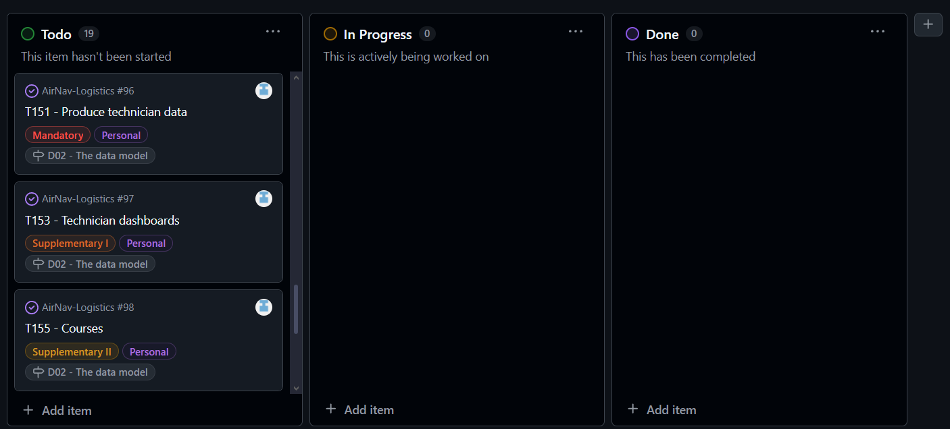

#### **2. Midway Through the Delivery: All Types of Tasks in Various Lanes**

#### **3. Final Task Completion in the "Done" Lane**

**Estimated Budget**

**Estimated hours by role:**

**Task 1:** **Meeting #3**

**Planned Time:** 1 hour

**Task 2: Meeting #4**

**Planned Time**: 1 hour

**Task 3: Technicians data model**

**Planned Time**: 1 hour

**Task 4: Maintenance Records (tasks) data model**

**Planned Time**: 1 hours

**Task 5: Produce technician data**

**Planned Time**: 30 minutes

**Task 6: Technician dashboards**

**Planned Time**: 30 minutes

**Task 7: Courses**

**Planned Time**: 1 hour

**Task 8: Analysis Report**

**Planned Time**: 30 minutes

**Task 9: Planning and progress report**

**Planned Time**: 1 hour

**Task 10: Theory lectures**

**Planned Time**: 6 hours

**Task 11: Follow ups**

**Planned Time**: 4 hours

**Task 12: Update workspace**

**Planned Time**: 30 minutes

**→Group requirements:**

**Task 13: Planning and progress report group**

**Planned Time**: 1 hour

**Task 14: System configuration**

**Planned Time**: 30 minutes

**Task 15: Aircraft Data Model**

**Planned Time:** 30 minutes

**Total Estimated Hours for Lucía Campos Díez:**  
**20 hours**

**Cost per role:**

**Developer (Lucía Campos Díez): €20/hour**  
**20 hours x €20 = €400**

**Amortization:**

* The amortization has been calculated using a linear method over three years, with an annual cost of €20.00 for the infrastructure used.

**Total Estimated Cost:**

* **Developer: €400**
* **Amortization: €20.00**
* **Total Estimated: €420**

**Progress Chapter**

#### **Progress Records**

|  |  |  |  |
| --- | --- | --- | --- |
| **Team Member** | **Performance Indicators** | **Value** | **Description** |
| Lucía Campos Díez | Task Completed | Good | All tasks completed on time and within the estimated time. |

### **Reward/Admonishment**

No formal reward was applied, but Lucía's efficient completion of tasks is noted as a positive contribution to the team's success.

### **Conflicts and Resolution**

No major conflicts arose during development. The team members worked collaboratively to address any technical challenges independently.

#### **Cost Comparison**

|  |  |  |
| --- | --- | --- |
| **Cost Component** | **Estimated Cost** | **Real Cost** |
| **Developer (Lucía Campos)** | **€400** | **€530** |
| **Amortization** | **€20.00** | **€20.00** |
| **Total Cost** | **€420** | **€550** |

### 

## 

## 

## **Conclusions**

The AirNav-Logistics project is progressing smoothly, with all tasks completed within budget and timeframe. The modifications have improved UI coherence, and documentation is aligned with project expectations.

## 

## **Bibliography**

Intentionally blank.